Data Warehouse Logical Design

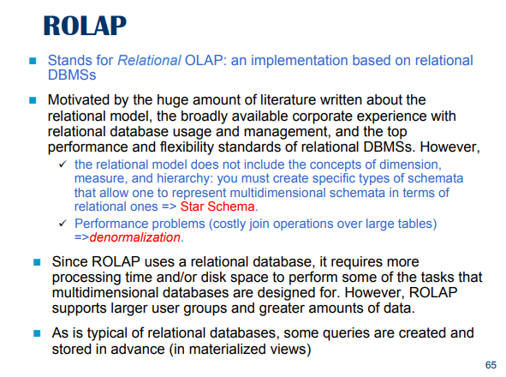
Relational Online Analytical Processing describes all techniques to do analytics. Start from fact schema (the data warehouse project) and try to fit the data in a standard relational database.

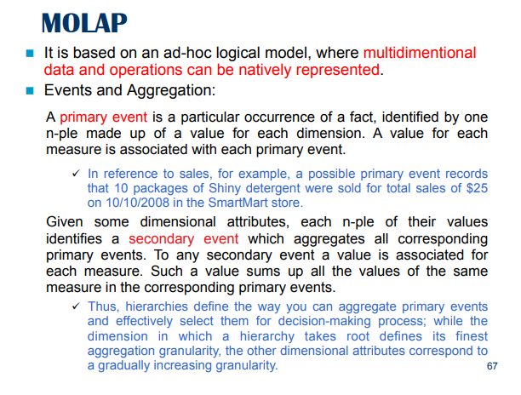
How to encode a data warehouse: second method MOLAP (multidimensional Online Analytical Processing)

Does not store data using table, save data as multidimensional array

Matrix allow to access element very fast (constant time).

A MOLAP store data using arrays, all concepts coming from data warehouse are implicit. A primary event is nothing else that a point identified by coordinates. Identified by one tuple.

Primary event: keys of dictionary such as
- shiny determined
- 10/10/2008
- SmartMart store

Values, the entity to access(?)
- Reference to sales
- 10 packages
- $25

We need an array for aggregation

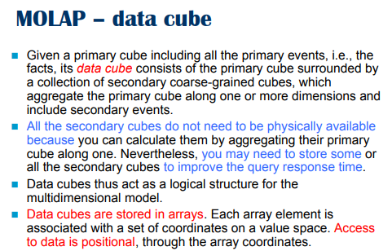

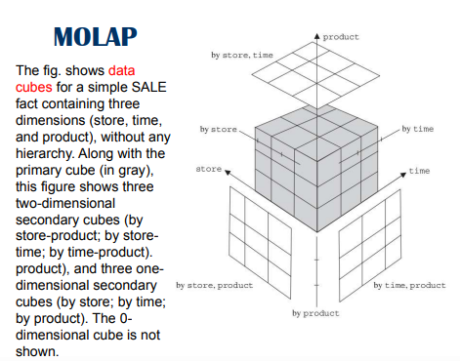
In gray we have the primary datacube which describes the primary events. Surrounding the primary cube we have a secondary cube that aggregate over a certain dimension. If we aggregate for a store dimension we move from a 3D cube to a 2D (aka secondary cube) because we aggregate over a dimension.

We can further aggregate a secondary cube (2D) by time and you get a 1D dimensional of cube

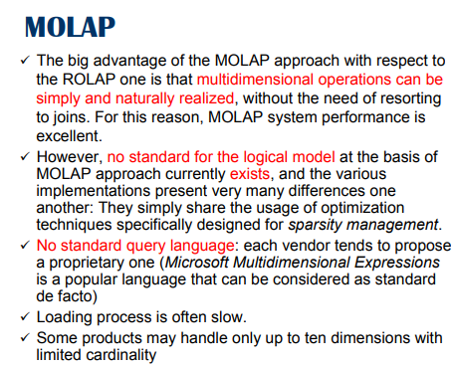

No standard methodology on how to implement the cube. Can use different data structures. No standard way to storage

Other disadvantage: no standard language to query the model.

Problem of sparsity (we can deal with this problem)

advantage: something very close to multidimensional operations, excel performance

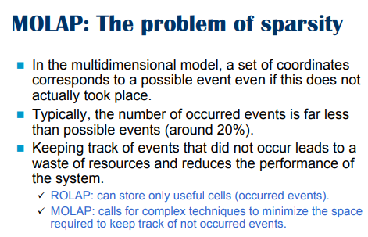
The number of events that really happen is a much smaller combination of the possible values for the dimensions.

To deal with sparsity the system must find a way to keep track of events that do not occur (but require CPU and computational power)
- ROLAP: store only occurred events, store in each row the events that happens. Each row match exact values
- MOLA: require to deal with sparsity in a different way with complex techniques

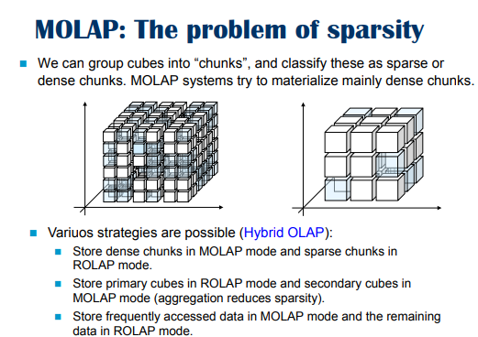
pick the cube and try to group it in chunks and classify as dense or sparse.

Store the dense part of the cube, while the spare are not actually stored.
⟹ have an impact, can not pick an arbitrary combination, I need to first check if the coordinates belongs to a dense or sparse chunk, if they are in a dense chunk I need to convert the coordinates

There is a hybrid approach, dense stores with array while sparse are stored in ROLAP. The secondary cube usually leads to less sparisty.

MOAL for dense data (and frequently access data), ROLAP for sparse data

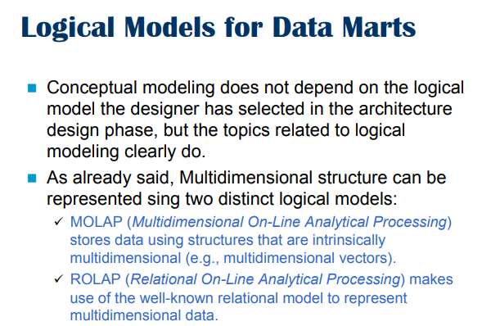

Conceptual modeling we do not care about logical.

Choose which technique to use

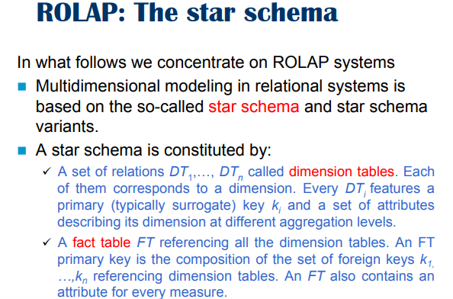

We use relational data model as a way to store relational facts.

There are millions way to store the fact schema

WE can use a star schema: if we peak the fact this is a description of a table in the middle that contains the measures.

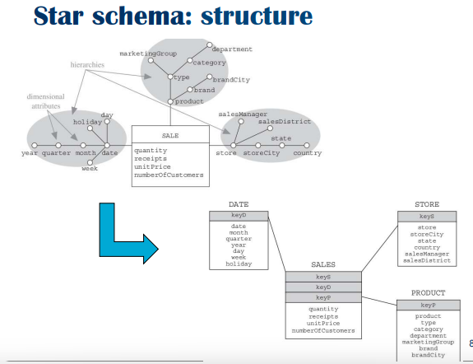
We have a sale with dimensions
- date
- product
- store

Sale is the fact name with 4 measures
- quantity
- receipts
- unitPrice
- numberOfCostumers

The conversion is a table with table sales where the attributes together forms the primary key of sales that are also a foreign key costraint of data, store, product.

data, store, product have as attribute their hierakies, problem; there is a lot of redundancy.
Like in the store table the store uniquely identifies a store city that uniquely determines the state, …

better to pay the price but to avoid the join.

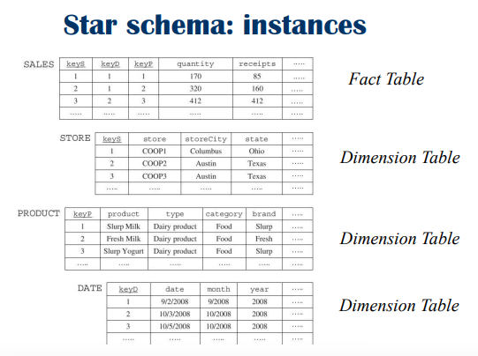

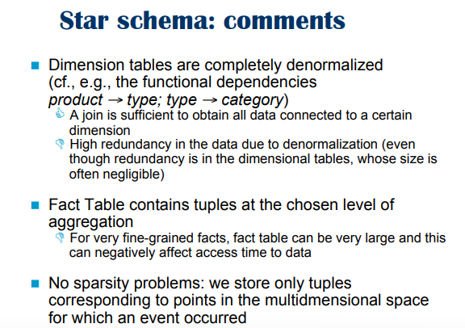

The star schema is completely denormalized: the attributes in each dimension table are related by a functional, each attribute determines the value of the other. If you know the value of an attribute you can know the value of the other attributes

⟹ no sparsity, you store in the fact table only the

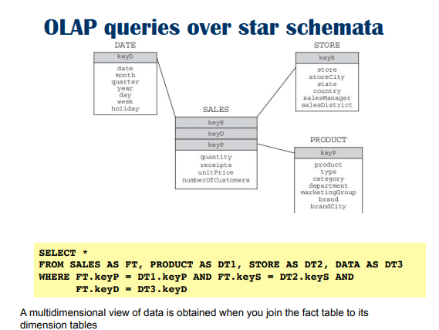
Join fact table with dimension table with the keys. This give you the primary events.

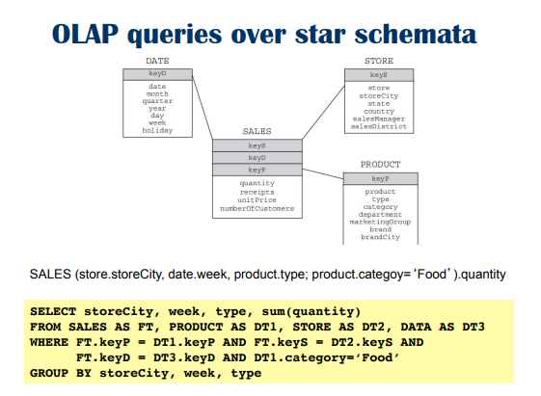
you can slides only with category food.

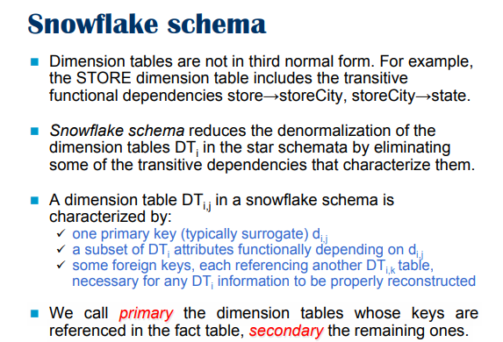
If you want to save space you can use the snowflake approach. Reduce the dimensions by eliminating transitive functional dependencies.

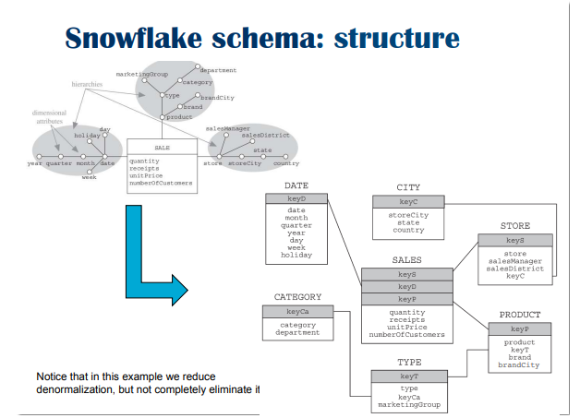
Sales fact table with the measures and the primary key. The difference is that if you pick the key of the store you reach the store table but you get only some information
- the name of the store
- SalesManager
- SalesDistrict
- KeyC
- a value that is a foray key to the city table that store city and the state and country (NOTE: we can have also more redundancy level, you could still split this)

DISADVANTAGE:
if you want to access a value is ok, but if you want to do aggregation you have to join multiple tables. We have to do many joints

